Completing Speech E-ballots on SpeechWire
Your coach should have already submitted your email address to the tournament manager during registration. If you already have a SpeechWire account, you will be able to use it to submit your e-ballots. If not, then at some point the management of the tournament should link your email address to a new SpeechWire account, at which time you will be emailed login details for the account at your email address.
You will access your e-ballots by going to the SpeechWire e-balloting website, which is at:
ballots.speechwire.com
There is also a link in normal SpeechWire coach accounts to the e-balloting login, but you can bypass that step by just going to ballots.speechwire.com directly.
If you need to reset your SpeechWire account password, you can do so at:
www.speechwire.com/forgot
Once on the ballots website, type in your email address and your SpeechWire account password.
Once you log in, you will see any ballots that you have been assigned on the home page:
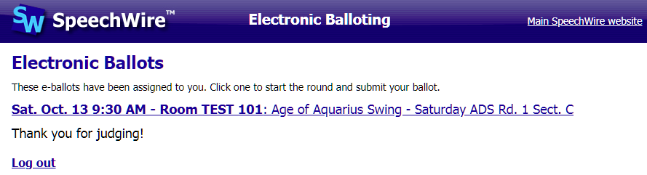
Click or tap the round that you are currently judging. If you have not yet started the round, a large highlighted link will let you mark that it has begun. Do this once they are in the room with competitors and the round is actually starting. This lets the tab room know that the room has started and that they don't need to worry about what's happening there.
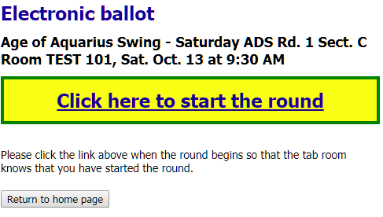
Once you start the round, you will see your electronic ballot.
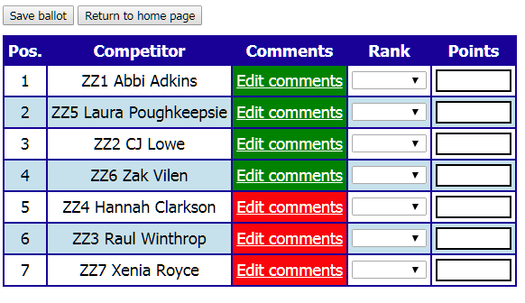
There are drop-downs where you can select the rank for each student, and a box to type in the points for each student. If a student is a no-show, you can select NOSHOW from the ranks drop-down and leave the points for them blank. Please note that you can only submit the ranks and points for the round ONCE! You cannot edit it later! If you make a mistake, you must go and let the tab room know!
As the round is happening, you can submit comments for each of the speakers using the "Edit comments" button on their line. The box will be highlighted in red for any students that you have not submitted comments for yet. Once you submit comments for them, it will turn green.
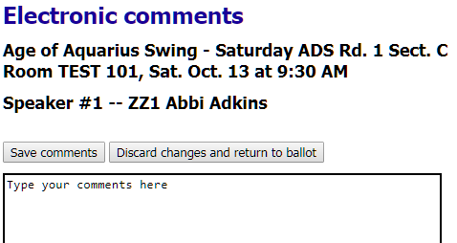
You can submit comments during the round, or you can submit your ranks and points first and then go back in and submit comments. Once the round is over, please submit your ranks and points as soon as possible, and then finish your comments! Please do not hold up the tournament by waiting to submit ranks and points.

A completed round will eventually look something like this:
